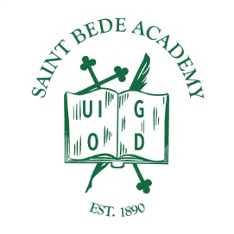
For Immediate Release
August 19, 2021
Contact: Eve Postula, Superintendent, epostula@st-bede.com

Saint Bede Academy to offer vaccination clinic to the public
PERU, ILLINOIS - The CDC and IPDH strongly encourage all individuals eligible for the COVID-19 vaccine to be vaccinated. Vaccination is currently the leading public health prevention strategy to end the spread of COVID-19. The administrative team at St. Bede Academy continues to closely follow the guidance of the CDC, IDPH, and local health departments to keep the students, staff and faculty of St. Bede Academy safe.

In an effort to assist in protecting our community, St. Bede Academy will host a COVID-19 Vaccination Clinic on Wednesday, August 25th from 1-4pm. The clinic will be open to students, faculty and staff during the school day as well as their families and the general public. Walk-ins are also welcome and no appointments are necessary. More information is available on the Saint Bede Academy’s website at www.st-bede.com.

###
Saint Bede Academy, located in Peru, IL is a college preparatory Catholic high school in the Benedictine tradition which endeavors to prepare their students for college and for life by welcoming them into a community of learning permeated by Christian values. Saint Bede Academy has been providing a quality Catholic education in North Central Illinois since 1890.

